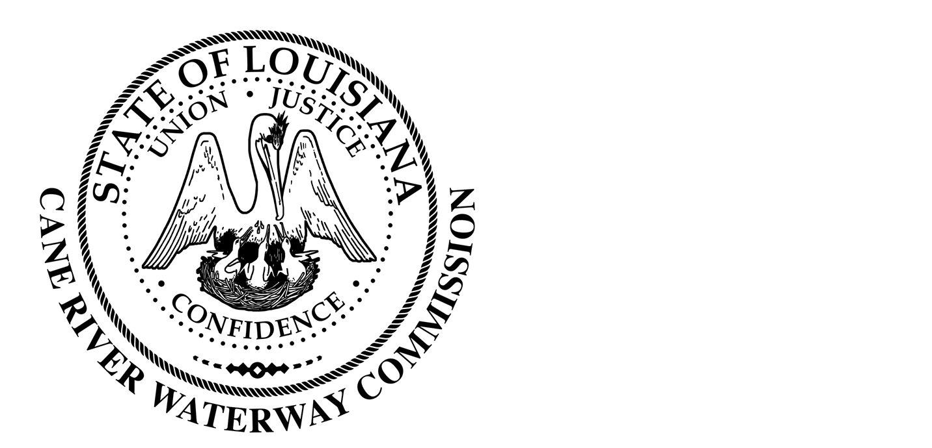
Cane River Waterway Commission
Minutes
January 18, 2023

There was a public hearing of the Cane River Waterway Commission on January 18, 2023, at 6:00 pm located at 244 Cedar Bend, Natchez, Louisiana.
The hearing was called to order and roll was called with the following members being present: Mr. Rhodes, Mr. Paige, Mr. Methvin, Mrs. Banks, Mr. Methvin and Mr. Wiggins.
Also present was Director of Operations Jason Adcock and Attorney Tommy Murchison.
The minutes of the regular meeting on November 15, 2022, were presented. The Chairman opened the floor to public comments and after discussion the Chairman closed the floor to discussion. Upon motion by Mr. Wiggins seconded by Mr. Methvin and unanimous vote by Mrs. Banks, Mr. Paige, Mr. Rhodes, Mr. Methvin and Mr. Wiggins, the Commission approved the minutes of the November 15, 2022, meeting as written.
Mr. Ralph Ingram requested permission to put a pump in the river on his property into the bayou the runs along his property. Mr. Ingram stated that he would need to cross his neighbor’s property to do so. Attorney Murchison advised Mr. Ingram that that would be between him and his neighbor. Mr. Rhodes advised Mr. Ingram that he did not need approval from the Commission.
District 2 Parish Councilman Bill Allen was present at the meeting. Mr. Allen stated that he wanted to thank the Commission for the support in his District with some of the road projects.
Mr. Jason Dewitt with Terminator was present and addressed the Commission about his companies spraying on Cane River. Mr. Dewitt also stated that he was running for District 25 State Representative which parts of Cane River runs through.
District 22 State Representative Gabe Firment was also present. Mr. Firment advised that some of his District covers the Cane River and he wanted to introduce himself and let the Commission know if there was anything he could do to help within his district to reach out.
Mr. Adcock presented the Commission with an Engineering agreement from Monceaux-Buller & Associates for the construction of the new parking lot and lighting at Washington Street. Upon motion by Mr. Wiggins, seconded by Mr. Paige and unanimous vote by Mr. Paige, Mr. Rhodes, Mr. Methvin, Mr. Wiggins and Mrs. Banks the Commission approved the hiring and agreement of Monceaux-Buller & Associates as lead engineers on the Washington Street parking lot expansion.
Mr. Rhodes presented an engagement letter from Corkern, Crews, Guillet and Johnson for the retainment of Attorney Chris Guillet as lead counsel for the Commission in any future lawsuits for physical year. Upon motion by Mr. Methvin, seconded by Mr. Paige and unanimous vote by Mr. Paige, Mr. Rhodes, Mr. Methvin, Mr. Wiggins and Mrs. Banks the Commission approved the engagement letter.
Mr. Adcock presented the Commission with the financial report from November 15-January 15, 2023. The Chairman opened the floor to public comment and after discussion the Chairman closed the floor to discussion. Upon motion by Mr. Wiggins, seconded by Mrs. Banks and unanimous vote by Mr. Paige, Mr. Rhodes, Mr. Methvin, Mr. Wiggins and Mrs. Banks the Commission approved the financial report.
There being no further business to come before the Board, upon motion by Mr. Methvin seconded by Mr. Wiggins and unanimous vote by Mr. Wiggins, Mrs. Banks, Mr. Paige, Mr. Methvin and Mr. Rhodes, the meeting was adjourned.

________________________________
Approved by
__________________
Date

